WHAT HAPPENS NEXT
God’s Plan for the Ages (Daniel 9)
September 28, 2025

Biblical prophecy is often the foretelling of future events. From God’s perspective—who is eternal, outside of time—prophecy is not a prediction of the future. It is a description of the future.

One of the greatest prophecies in the Bible is found in Daniel 9. This amazing prophecy not only details the first coming of Jesus Christ, but also events just prior to his return! Daniel 9 is called “the backbone of Bible prophecy.”
Daniel 9:24-27: the angel Gabriel tells Daniel what will happen to his people, both at Messiah’s coming (and rejection); and his return (the Great Tribulation period of 7 years).
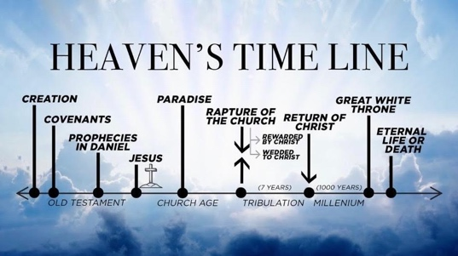

Gabriel spoke three distinct prophecies to Daniel in this vision:
- A spiritual revival for the Jews that would happen in 490 years (70 sets of 7).
(this is future, and it has not yet been fulfilled).
- The coming of the Messiah, which would take place 483 years (or 69 sets of 7) after the declaration to rebuild Jerusalem. Artaxerxes issued this decree in 444 BC (to Nehemiah). And that Messiah would be “cut off” from his own people. This happened in approximately 32 AD).
- The third prophecy is connected to the future, those final seven “years”, which represent the great tribulation just prior to Christ’s glorious return.

In between Daniel 9:26 and 9:27 there is what Jesus calls “the times of the Gentiles” (see Luke 21:24): “Jerusalem will be conquered and trampled down by the Gentiles until the age of the Gentiles comes to an end.” This is called “the Church Age” and we are in it now.

